**Annotation Webpage Design Update**

***Week 5. Version 1_Initial Design***

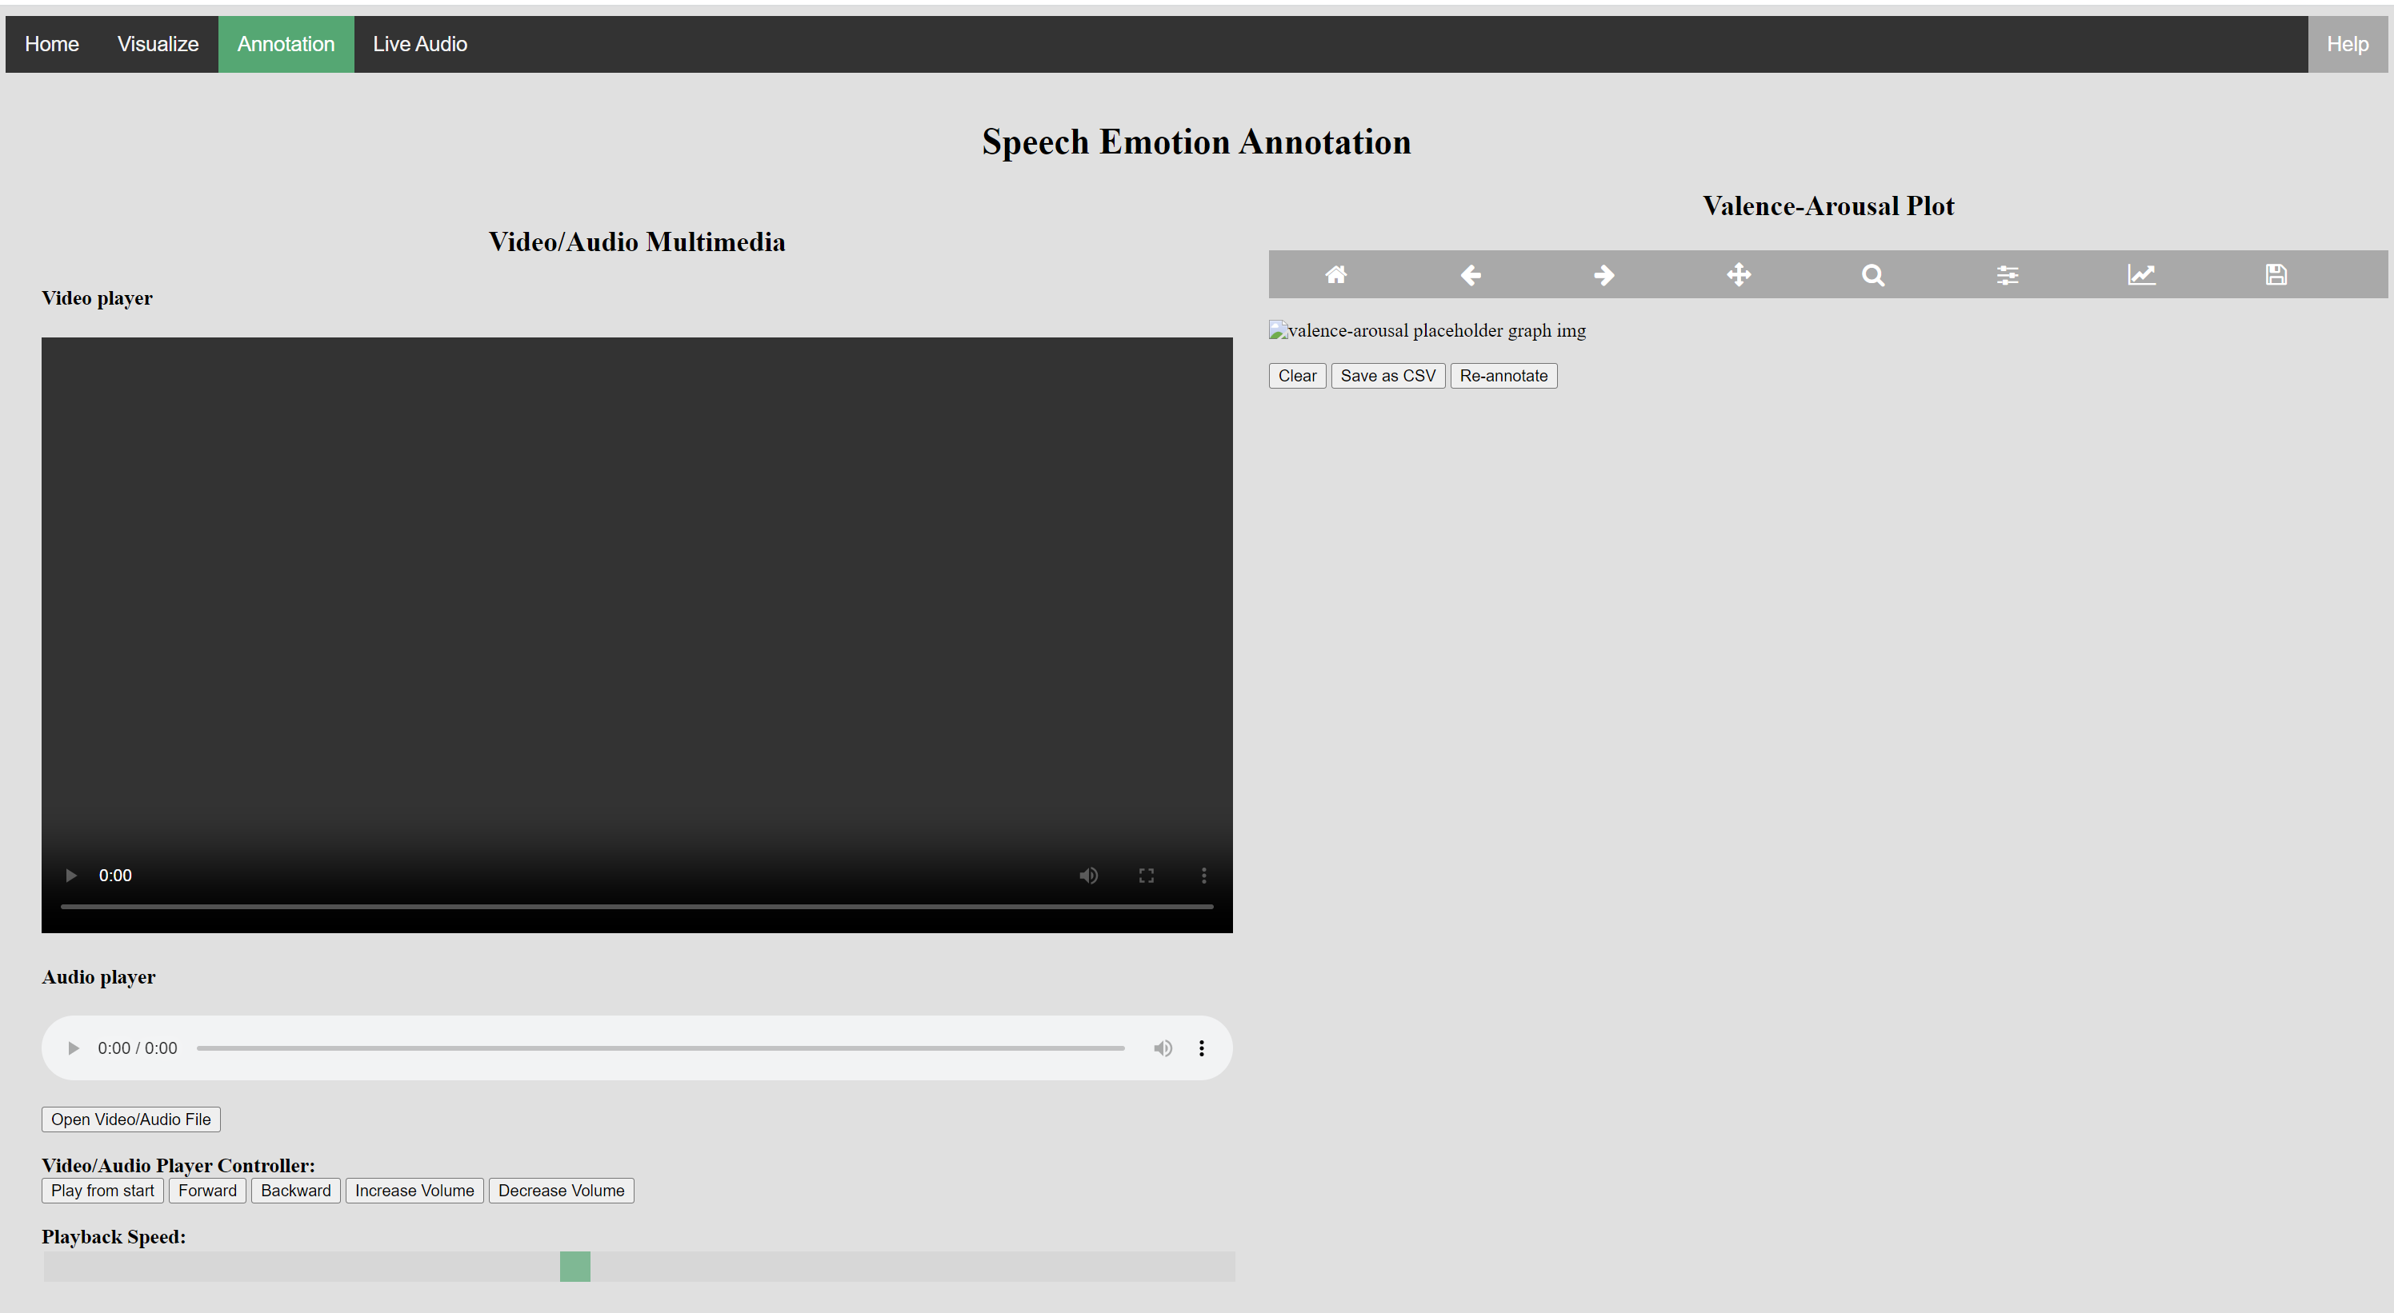

***Week 6. Version 2_ Load video/audio files***

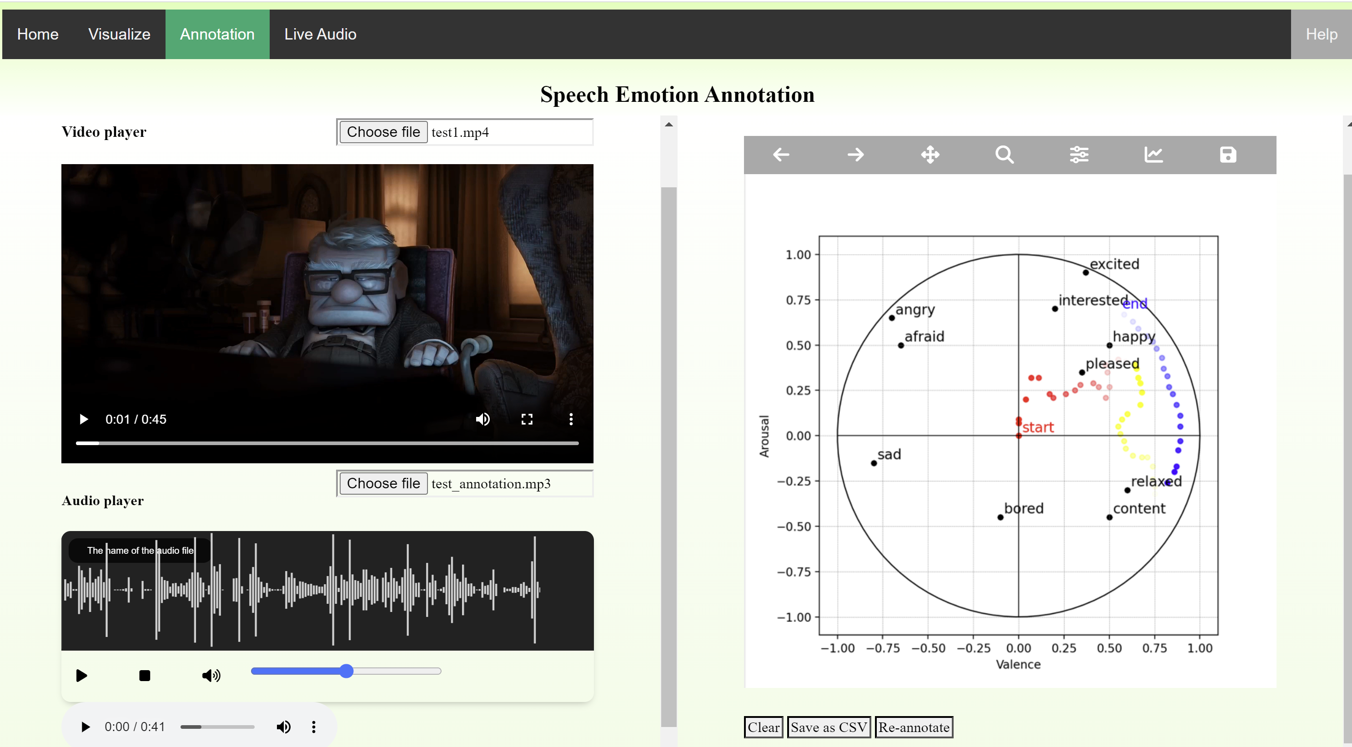

* Mp4 video files loaded on the player successfully, not playing .wmv files
* Audio player needs to have a player control button implemented manually: not working yet
  + Built-in audio player can’t be used in order to sync with waveform display
* Audio waveform displayed using wavesurfer.js

***Mid term break***

***19 June***

Created Tab-based interface for multimedia players

